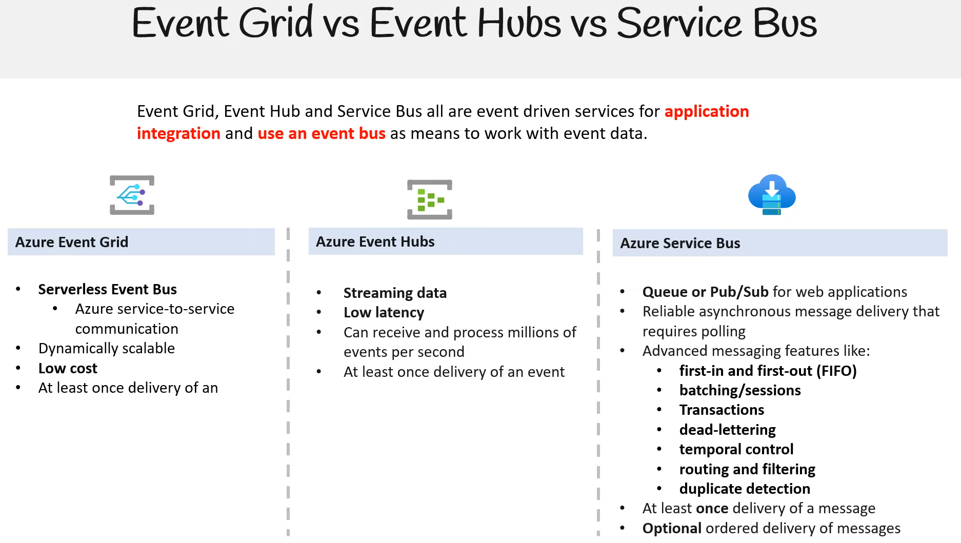

[Compare Azure messaging services - Azure Event Grid | Microsoft Learn](https://learn.microsoft.com/en-us/azure/event-grid/compare-messaging-services)

High-level definition:

* **Azure Event Grids** – Event-driven publish-subscribe model (think reactive programming)
* **Azure Event Hubs** – Multiple source big data streaming pipeline (think telemetry data)
* **Azure Service Bus**- Traditional enterprise broker messaging system (Similar to Azure Queue but provide many advanced features depending on use case [full comparison](https://learn.microsoft.com/en-us/azure/service-bus-messaging/service-bus-azure-and-service-bus-queues-compared-contrasted))

*Difference between****Event Grids****&****Event Hubs***

1. **Event Grids** doesn’t guarantee the order of the events, but **Event Hubs** use partitions which are ordered sequences, so it can maintain the order of the events in the same partition.
2. **Event Hubs** are accepting only endpoints for the ingestion of data and they don’t provide a mechanism for sending data back to publishers. On the other hand, **Event Grids** sends HTTP requests to notify events that happen in publishers.
3. **Event Grid** can trigger an Azure Function. In the case of **Event Hubs**, the Azure Function needs to pull and process an event.
4. **Event Grids** is a distribution system, not a queueing mechanism. If an event is pushed in, it gets pushed out immediately and if it doesn’t get handled, it’s gone forever. Unless we send the undelivered events to a storage account. This process is known as dead-lettering.
5. In **Event Hubs** the data can be kept for up to seven days and then replayed. This gives us the ability to resume from a certain point or to restart from an older point in time and reprocess events when we need it.

*Difference between****Event Hubs****&****Service Bus***

To the external publisher or the receiver **Service Bus** and **Event Hubs** can look very similar and this is what makes it difficult to understand the differences between the two and when to use what.

1. **Event Hubs** focuses on event streaming where **Service Bus** is more of a traditional messaging broker.
2. **Service Bus** is used as the backbone to connects applications running in the cloud to other applications or services and transfers data between them whereas **Event Hubs** is more concerned about receiving massive volume of data with high throughout and low latency.
3. **Event Hubs** decouples multiple event-producers from event-receivers whereas **Service Bus** aims to decouple applications.
4. **Service Bus** messaging supports a message property ‘Time to Live’ whereas Event Hubs has a default retention period of 7 days.
5. **Service Bus** has the concept of message session. It allows relating messages based on their session-id property whereas Event Hubs does not.
6. **Service Bus** the messages are pulled out by the receiver & cannot be processed again whereas Event Hubs message can be ingested by multiple receivers.
7. **Service Bus** uses the terminology of queues and topics whereas **Event Hubs** partitions terminology is used.

Use this loose general rule of thumb.

SOMETHING HAS HAPPENED – **Event Hubs**

DO SOMETHING or GIVE ME SOMETHING – **Service Bus**